The Student Life reports can be found on CX10 and on Cognos. The following steps show how to run a Cognos report (for example, Minority Report).
- Login to https://cognos.huntington.edu using your HU login and password.
- Once logged in, on the left side menu select “Team Content”.

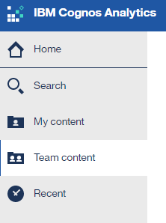

- Scroll down to “Student Services Reports” and click on it.

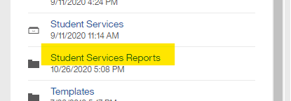

Scroll down to Minority Report and then click on “…” to the right to select “Run as” and select the appropriate format.

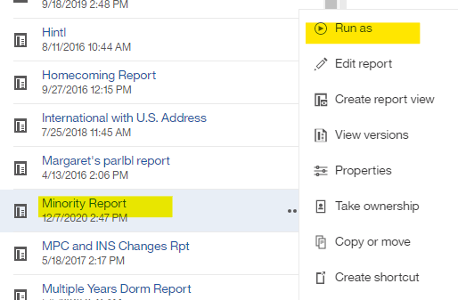

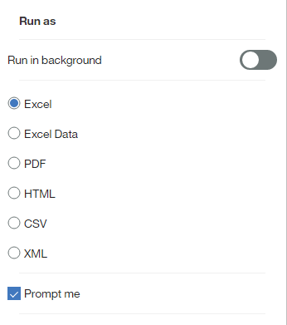
Make sure to select “CX ODBC” and complete the following prompts for session and year and select “OK” button at the bottom of the screen.
