Setting Up Microsoft Bookings

Microsoft Bookings is a service that allows people, for example, students, parents, and other faculty and staff to book appointments to meet with you.
Microsoft Bookings is tied into your HU calendar, so when people book a meeting, a meeting event will automatically be created in your HU calendar. Also, if you have other events in your calendar, they will automatically be blocked off so that people cannot book them from Bookings.
Below are steps for setting up your Microsoft Bookings calendar.
- Go to the HU Portal at my.huntington.edu and click on HU Email
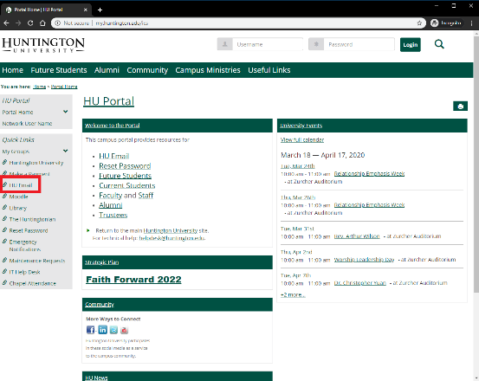
- Sign in with your HU email address and password
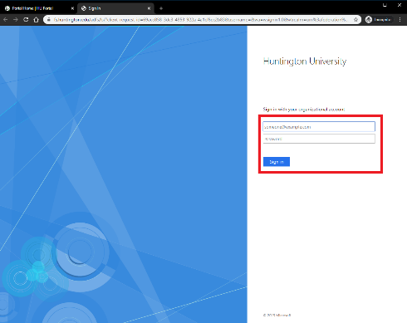
- Click on the nine dots in the upper left corner
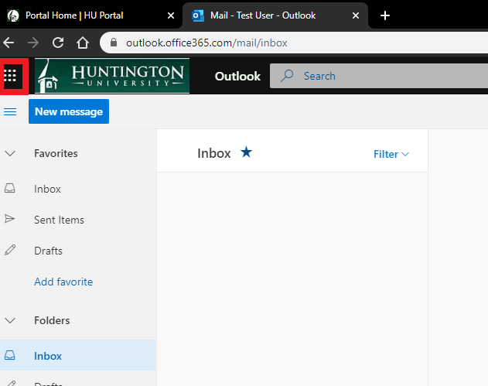
- Click on All Apps
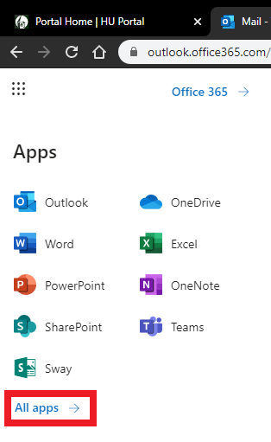
- Click on Bookings
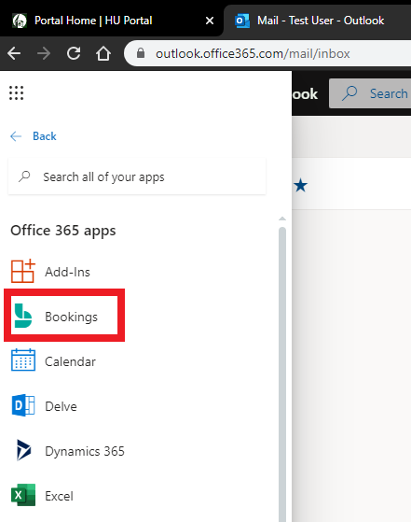
- Click on Get it now
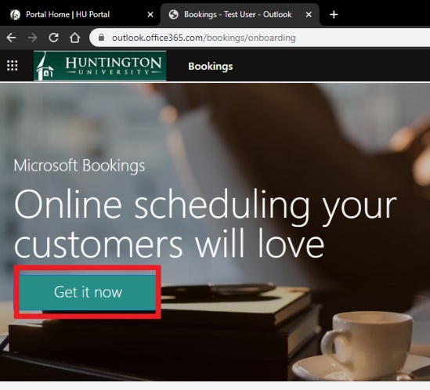
- Click Add a booking calendar
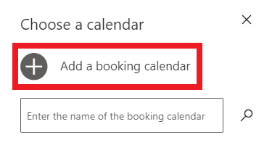
- Enter a name for your Microsoft Bookings page. Even though the field mentions company, do not use Huntington University as the company, but rather the name you want to you for your specific Bookings page. In my example, I am using 1-on-1 Meetings for Tim Bard. Click Continue
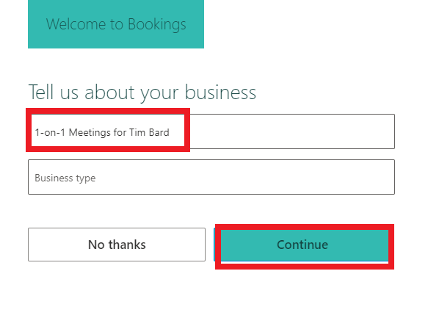
- Click on Business Information
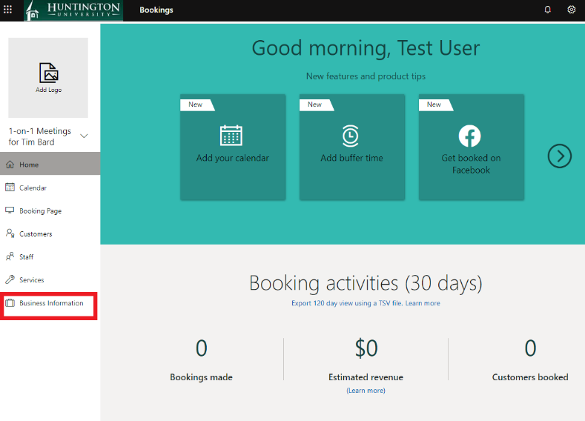
- On this page, you can set some basic information about yourself as well as set your meeting availability.
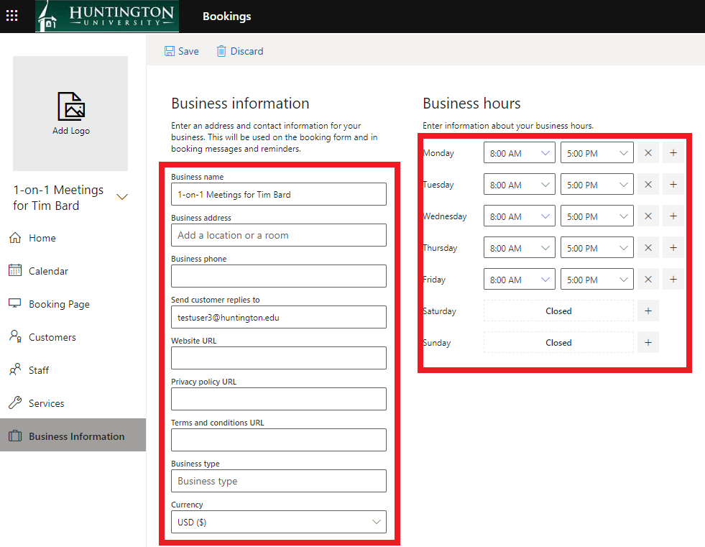
- By default, your hours are set to 8AM-5PM M-F. To change a time, you can click on the dropdown box; to remove a time, you can click on the x; to add a time, you can click on the +. In this example, I used the dropdown box to change my available on Friday to be 8AM – 12PM. I then used the + box to add a time slot of 1PM – 5PM on Friday. By doing this, I have created a lunch hour for myself from noon - 1PM on Friday. Faculty my want to change the business hours to reflect, for example, their office hours.
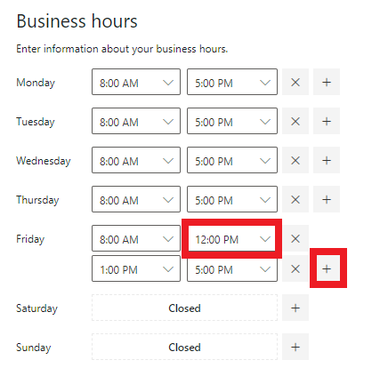
- After you have entered the information on this page, make sure you click save.
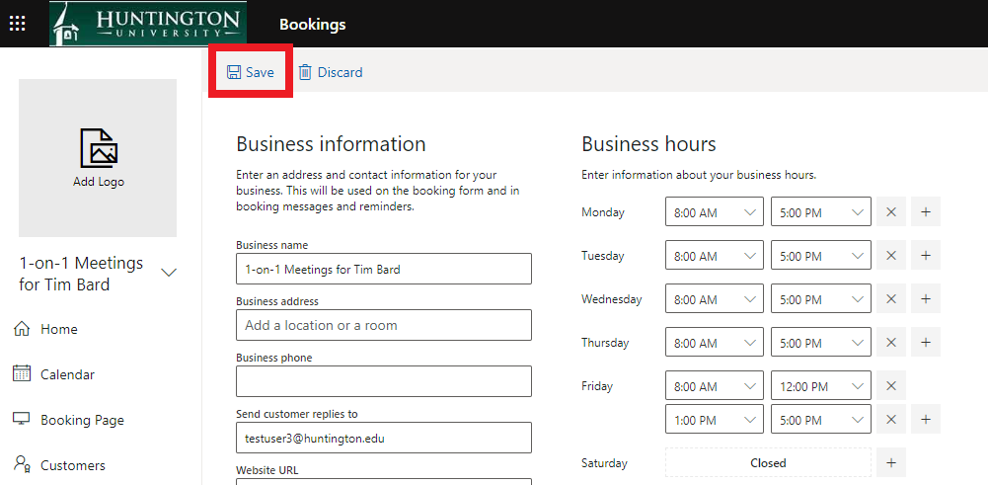
- Now that you have entered your hours, you will want to set up the services students can sign up for. For faculty, individual services may be “Advisory Meeting” or services for each of your classes. This will give you the opportunity to know why the student wants to meet with you and prepare accordingly; you also have the ability to set the default duration of the meeting based on the service. Perhaps you want meetings concerning class to be 15 minutes in length, but advisory meetings to be 30 minutes.
To work with services, click on Services
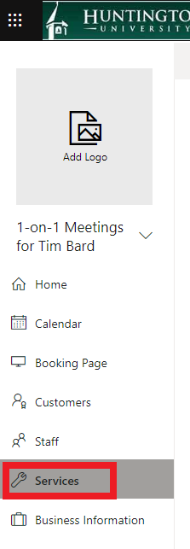
- By default, there is a service called Initial Consult already created for you. Hover on the service and click on the Pencil icon that appears.
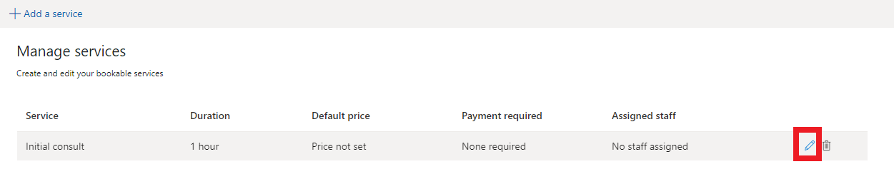
- On this page, you can choose a Service name, Description and Duration. Do not choose the Add online meeting option, as that will create a Teams meeting for the Booking.
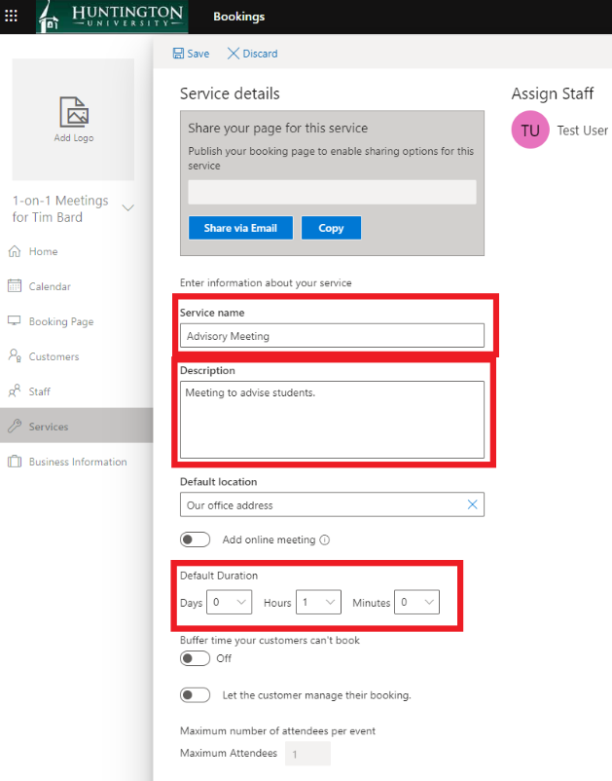
- The page includes additional options that you are welcome to review and change, but you can leave them at their defaults. Make sure you click Save when you are finished.
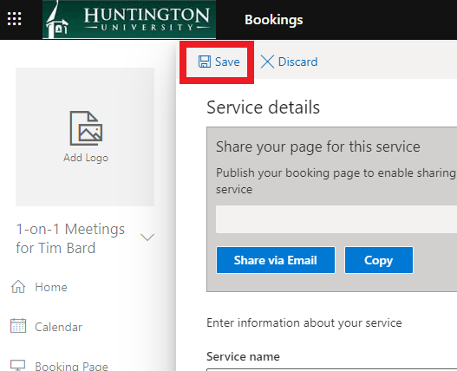
- You can add additional services by clicking on the Add a service button.
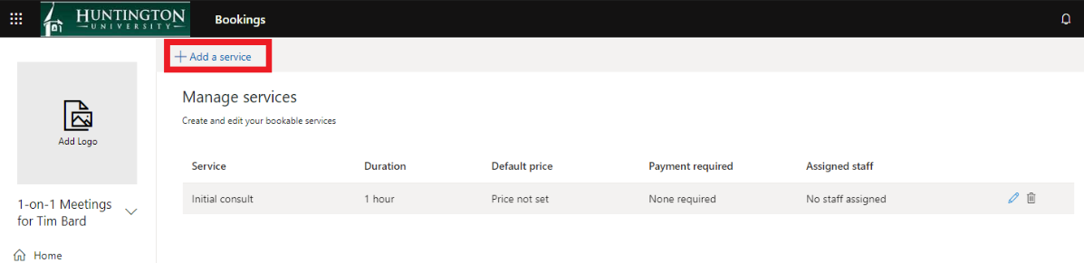
- Once you have added all your services, you can publish your Microsoft Bookings site so that people can start booking times with you. Click on Booking Page.
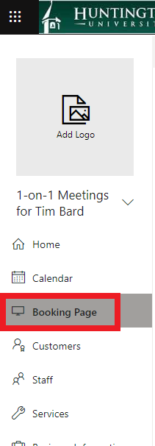
- On this page, you will want to review and change, if necessary, the Scheduling policy.
Having time increments of 30 minutes means people can book meetings either on the hour or 30 minutes into the hour. Increments of 15 minutes means people can also book meetings 15 minutes into the hour and 45 minutes into the hour.
Lead time refers to how much time in advance a person can book a meeting with you. A minimum lead time of 24 hours requires a person to book at least 24 hours ahead of time. A minimum lead time of 4 hours allows a person to book a time with you on the same day as the meeting, but requires at least 4 hours’ notice. A maximum lead time is how far into the future a person can book a time with you. A maximum lead time of 365 days means a person can not book a time with you that is more than a year in the future. If do not want people to book a time with you more than a month in the future, you can set the maximum lead time to 30 days.
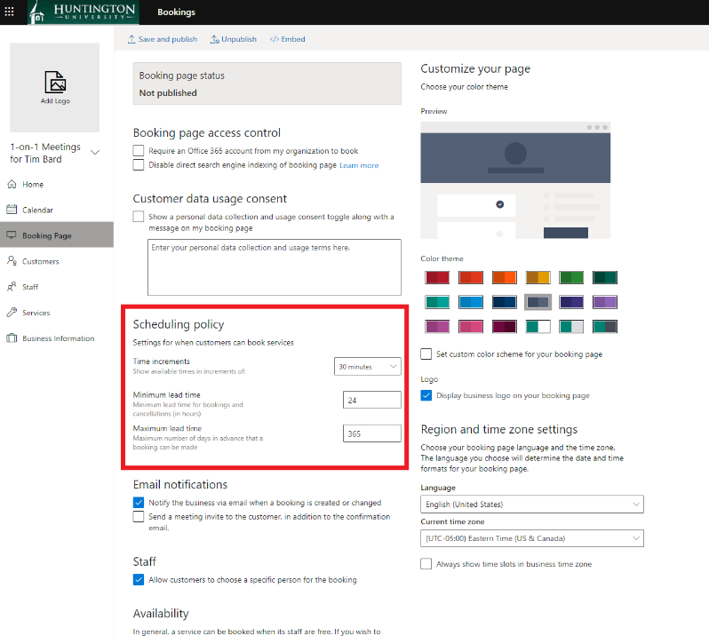
- You can change other settings as well, but the Scheduling policy is the most important. Once you are finished, click on the Save and publish option.
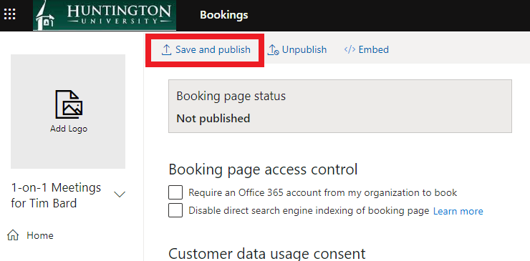
- After publishing your Microsoft Bookings site, you will be able to provide users with a link to the site and they can start booking times. To provide the link to people, first click the Copy button.
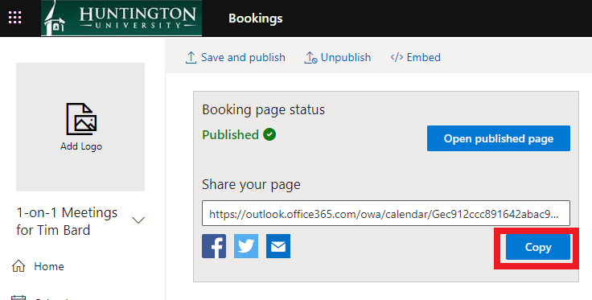
- A new window will appear with the highlighted link. Simply press Ctrl+C if you are using Windows or Command+C if you are using a Mac.
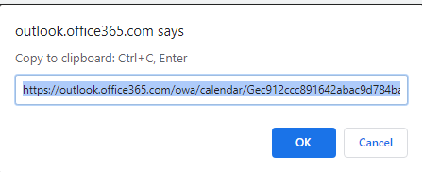
- At this point, you can paste the link to the location of your choice, for example in Moodle or in an email, by pressing Ctrl+V or Command+V.
- At that point, you can use the link to test out the booking page. Below is an example of my booking page, which can be accessed from the link below. On my Bookings page, you can see the various services that I offer and the amount of time I have allocated for each service. People can choose a service, a date and then a time to book with me.
https://outlook.office365.com/owa/calendar/TimothyBard@huntingtonedu.onmicrosoft.com/bookings/
